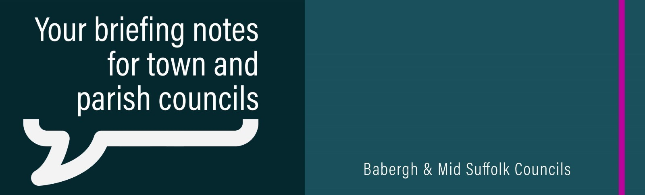

Increased bin collections set to herald ‘recycling revolution’
Residents in Mid Suffolk will get more opportunities to recycle from 2026 as part of nationwide changes to waste collections.

Councils renew call for urgent government action to end council housing funding crisis
Mid Suffolk District Council has renewed its call for urgent government action to end the financial crisis that is currently facing council housing.

Suffolk councils join forces to urge government to save council homes
Mid Suffolk District Council supports five-point action plan being put to the Government.

Councils issue response after devolution deal scrapped
Mid Suffolk District Council has added its voice to a joint statement following the news that a proposed Suffolk devolution deal has been scrapped by the Government.

Have your say on our new economic strategy
Babergh and Mid Suffolk District Councils are developing a new economic strategy and want to hear your views.

‘We will protect our heritage’ – Council’s pledge as Shrubland Hall owner fined
The owner of Grade II* listed Shrubland Hall has been fined £3,600 after two structures were erected on the historic estate without planning permission.

Developer cash set to help preserve local history and update community facilities
Babergh and Mid Suffolk communities are set to see more than £836,000 injected back into local projects.

Councils to plug employment skills gap for local businesses
An innovative project designed to support people into employment, including help for those facing mental health challenges in the workplace, has been launched.

Lifetime of funding for biodiversity projects secured
A number of communities are set to benefit from a lifetime of funding for biodiversity projects as part of a developer’s planning agreement with Mid Suffolk District Council.

Half term activities
Children in Babergh and Mid Suffolk will be able to get involved in a wide range of activities during the October half term. From swimming to soft play, soccer schools to arts and crafts, there’s plenty on offer for families across the districts.

Community Emergency Plans
As we approach the first anniversary of Storm Babet, we remind any town or parish Council interested in developing a new Community Emergency Plan or refreshing an existing plan to contact us at EmergencyPlanning@baberghmidsuffolk.gov.uk.

