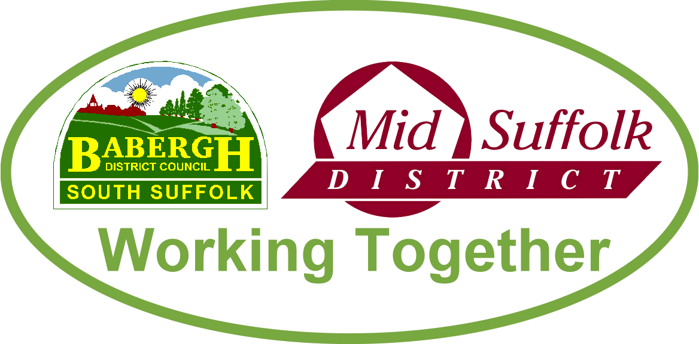
March 2022

Mid Suffolk District Council freezes council tax but investment in recovery to continue
Mid Suffolk District Council has frozen its element of council tax this year – helping residents through post-pandemic recovery while still investing in priority areas to improve quality of life. Read the full story.

Suffolk agencies respond to storm challenges
Babergh and Mid Suffolk District Council teams joined the multi-agency response to a major incident as Storm Eunice hit Suffolk. Read the full story here and here.

Babergh and Mid Suffolk District Councils respond to new ‘County Deal’
The leaders of Babergh and Mid Suffolk District Councils welcomed news that Suffolk is one of nine counties invited to negotiate a ground-breaking devolution deal – bringing more control over areas such as transport, infrastructure and skills to the region. Read the full story

Welcome to Mid Suffolk’s newest councillor
Cllr Austin Davies was elected District Councillor for the Thurston ward in February’s by-election. See website for the results in full

Switch onto a new Digital Skills Programme for businesses
Business owners in Babergh and Mid Suffolk who want to learn new or improve their digital skills can now access free courses as part of a new business support programme. Read the full story

A new bigger, better library for Needham Market!
Suffolk Libraries and Mid Suffolk District Council are excited to announce that the new Needham Market Library is now open. Read the full story

Additional funding to support districts’ rough sleepers
Babergh and Mid Suffolk District Council have been awarded £324K to provide specialised emergency accommodation for rough sleepers and those at risk of homelessness. The funding, from the Ministry of Housing, Communities & Local Government’s Rough Sleepers Accommodation Programme, will see new energy efficient homes in Stowmarket and Sudbury, to provide emergency accommodation for vulnerable adults at risk of living on the streets. Read the full story

Empty Homes Week (Feb 28-March 4)
Babergh and Mid Suffolk District Councils are reminding anyone struggling to renovate properties of the Empty Homes Renovation Loan. The loan is designed to help transform vacant properties which have been empty for more than six months and are in need of significant repairs. Read the full story.

Nine new affordable home in Botesdale for local residents
Nine affordable homes opened their doors to new households this month, following the completion of a new development in Botesdale. Read the full story

School’s Out activities to support families through half-term
Football, swimming, crafts and outdoor cooking, were amongst the fun activities on offer from Babergh and Mid Suffolk District Councils and partners during the February half-term school holidays. Read the full story

New Government rebate
On 3 February, the Government announced measures to help protect millions of households from rising energy costs - including a ‘£150 council tax energy rebate’. Read the full story

Babergh and Mid Suffolk pledge their support to addressing violence against women and girls
Babergh and Mid Suffolk District Councils have signed up to a new county-wide strategy, outlining how Suffolk will address violence against women and girls. Read the full story

Congratulations Your Majesty
Babergh and Mid Suffolk District Councils sent congratulations to Her Majesty the Queen on the 70th anniversary of her accession to the throne. Read the full story

Constituencies are changing - have your say now
The Boundary Commission for England (BCE) is required by Parliament to undertake an independent and impartial review of all constituencies in England, to rebalance the number of electors in each constituency. Read the full story

Bird Flu outbreak near Elmswell
The UK’s Deputy Chief Veterinary Officer has confirmed highly pathogenic avian influenza (HPAI) H5N1, commonly known as bird flu, at a small holding near Elmswell. A 3km Protection Zone and a 10km Surveillance Zone have been put in place around the infected premise to limit the risk of the disease spreading.

All poultry keepers – whether commercial farmers or those with a small backyard flock – are required by law to house poultry, or otherwise, to keep them separate from wild birds. Read the full story

