# Wilby Parish Council AGENDA

## To: Members of Wilby Parish Council

You are duly summoned to attend the next meeting of Wilby Parish Council to be held at 7.00pm on Thursday 20th March 2025 at Wilby Primary School.

## Public Attendance

Members of the public and press are welcome to attend. At item 9, the public will be invited to give their views/question the Parish Council on issues on the agenda, or raise issues for consideration of inclusion at future meetings. This item will generally be limited to 15 minutes duration.

# AGENDA

## Chairman’s welcome

## Apologies and approval of absences

## (a) Councillors to receive any apologies for absence

## (b) Councillors to **vote** on acceptance of any apologies received

1. **To receive Declarations of Interest**

Councillors to declare interests in subsequent agenda items as follows:

(a) Pecuniary Interests

(b) Other registerable interests

(c) Non-registerable interests

1. **To consider requests for dispensations**
2. **Councillor vacancies: To review any applications for co-option**

5.1 One application received

[Declaration of Acceptance of Office](../../Co-Option/Declaration%20of%20Acceptance%20of%20Office.docx)

1. **To resolve that the minutes of the meeting of the council held on 22nd January 2025 are a true and correct record.**
2. **County and District Councillors & Footpath and Tree Warden Reports**

(a) Tree Warden

(b) Footpath Warden - vacant

(c) Cllr Linder’s report [here](../Cllr%20Reports/2024/Report%20March%2025.docx)

(d) Cllr Lloyd’s report [here](https://www.henryjameslloyd.com/p/my-march-county-report)

Councillors to raise any questions on submitted reports

1. **To receive Action Log updates/progress reports for information on the following:**
   1. Highways
      1. Traffic survey funding
      2. Village Gates
      3. Road markings
      4. Baffle gates
   2. Website
      1. Quotes forwarded to Councillors for final decision making.
   3. Banking
   4. VETS Defibrillator
      1. Update on training
      2. Potential collaboration with Brundish
   5. Wilby Green
      1. Summary of Wilby Green
      2. Motion to resolve removal of signage at Wilby Green

## Public participation session (15 minutes)

## Councillors to receive questions or comments from the public on agenda items

1. **To consider planning applications**

No planning applications for consideration

1. **Finance**

(a) To approve the updated [Asset Register](../../Finance/2024-2025/Asset%20Register%202024-25.xlsx) including the following disposals:

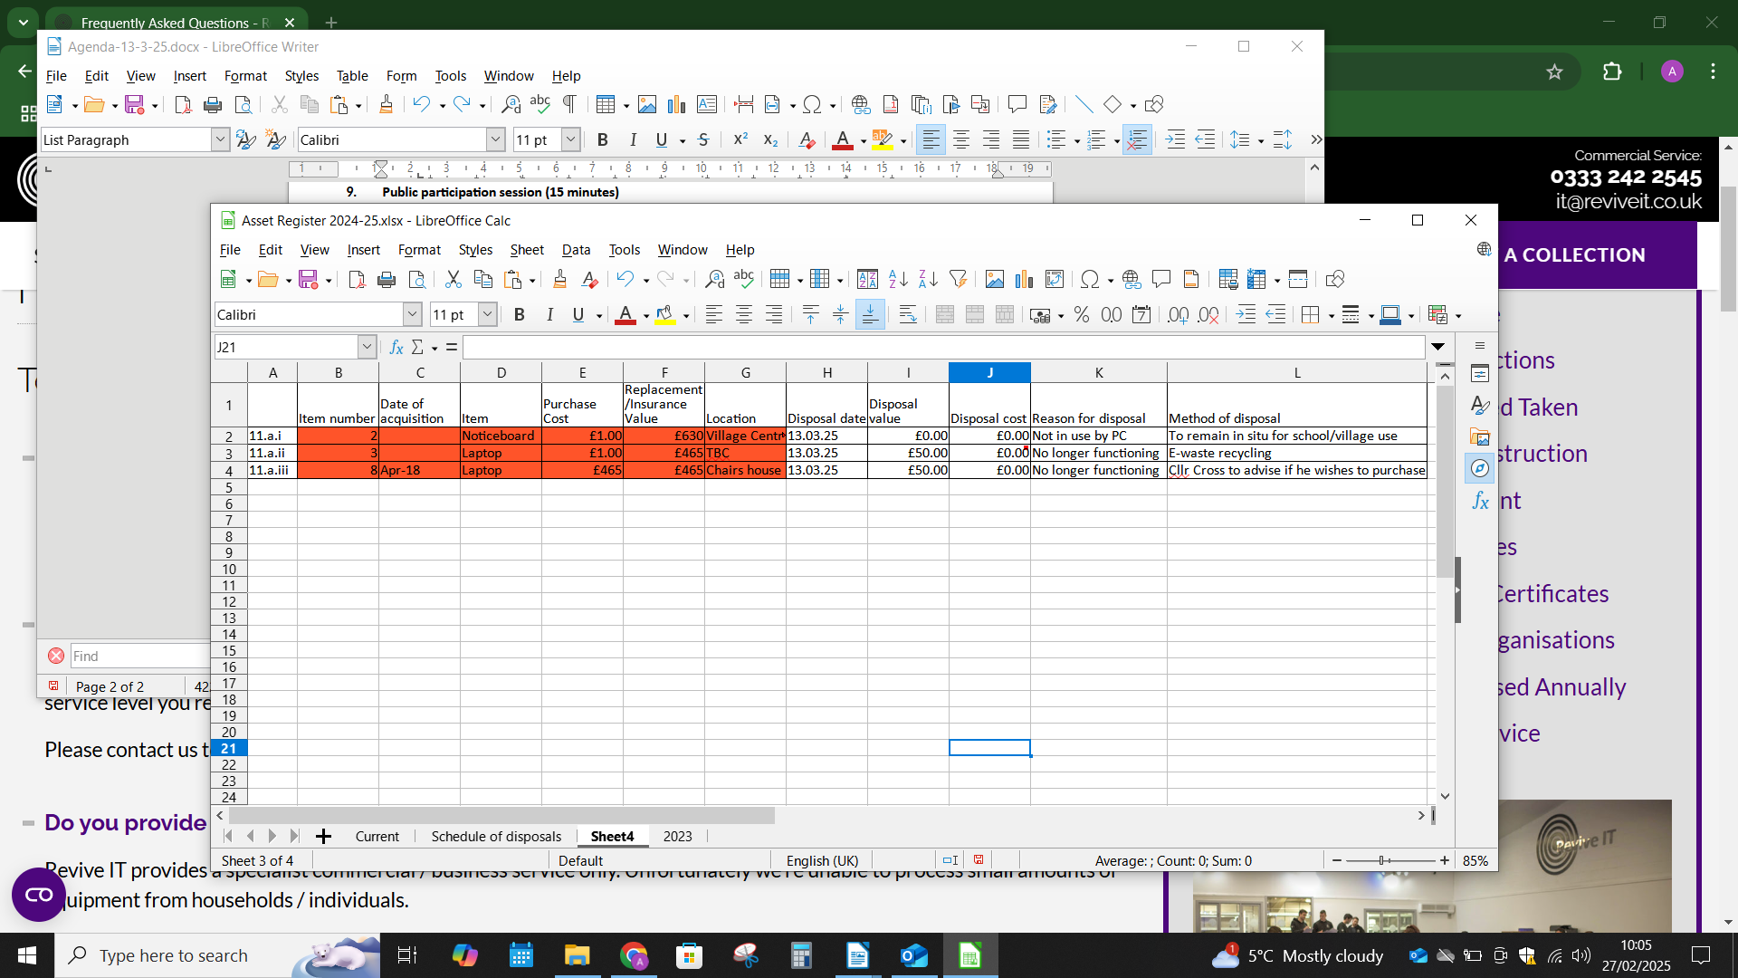

(b) To approve [Finance Report](../../Finance/2024-2025/Reconcilliation%202425.xlsx)

* + 1. Bank Reconciliation [here](../../Finance/2024-2025/Reconcilliation%202425.xlsx)
    2. Budget to Actual
    3. Receipts and Payments since last meeting

(c) To authorise payments listed below:

### None

(d) To authorise direct debit mandate for ICO

(e) To receive payments listed below:

i. JR Rix Rebate: £66.79

ii. MSDC traffic survey: £730

1. **Policies for review**

(a) [Risk Assessment 24/25](../../Policies/Risk%20Assessment%202024-2025.docx)

1. **To discuss the Clerk receiving Home Working Allowance:** [**More information here**](https://www.salc.org.uk/blog/payroll-24/homeworking-allowance-379)

(a) Motion to approve Home Working Allowance for the Clerk (£6 per week)

(b) Motion to approve backdating Home Working Allowance for the Clerk (£TBC)

1. **Items for consideration for inclusion on the next agenda**
2. **Correspondence for Information**

Email from David Barker – Evolution Town Planning in relation to meeting with the PC.

## Items from Parish Councillors

## Date of next meeting

To confirm the date of the next meeting – The Annual Parish Council Meeting and the Annual Parish Meeting, scheduled for 8th May 2025.

*A. Clarke*

*Clerk to the Council*